1. **What is SDLC ?**

* Software development life cycle is a step by step process used to create software. It include planning , designing , building , testing and maintaining the software . its step ensure the final product high quality and meets user needs.

1. **What is Software Testing ?**

* Software testing is a process used to identify the correctness , complitness and quality of development computer software

1. **What is SRS?**

* Srs stand for software requirement specification, it is a detail document that describe the functional and non-functional requirements ,as well as expect behaviour of a system.

1. **What is agile methodology?**
2. **What is oops?**

* Oops is a programming paradigm that organizes software designand around data , or objects , rather than functions and logic.

1. **Write Basic Concepts of oops ?**

* Class
* Object
* Inheritance
* Polymorphism
* Encapsulation
* Abstraction

1. **What is object?**

* Object given the permission to access functionality of class.

1. **What is class?**

* Class is collection of data member and member function.

1. **What is encapsulation ?**

* The process wrapping the data in single unit to secure the data outside world.

1. **What is inheritance ?**

* Making a class from an existing class. Driven the attribute the some other class

1. **What is polymorphism ?**

* One name multiple from.

1. **Draw Use case on Online book shopping ?**

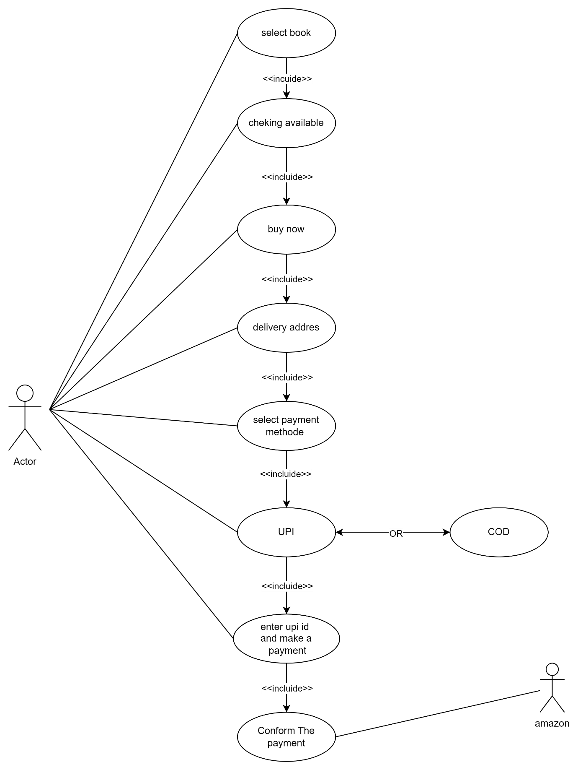

1. **Draw Usecase on online bill payment system (paytm) ?**

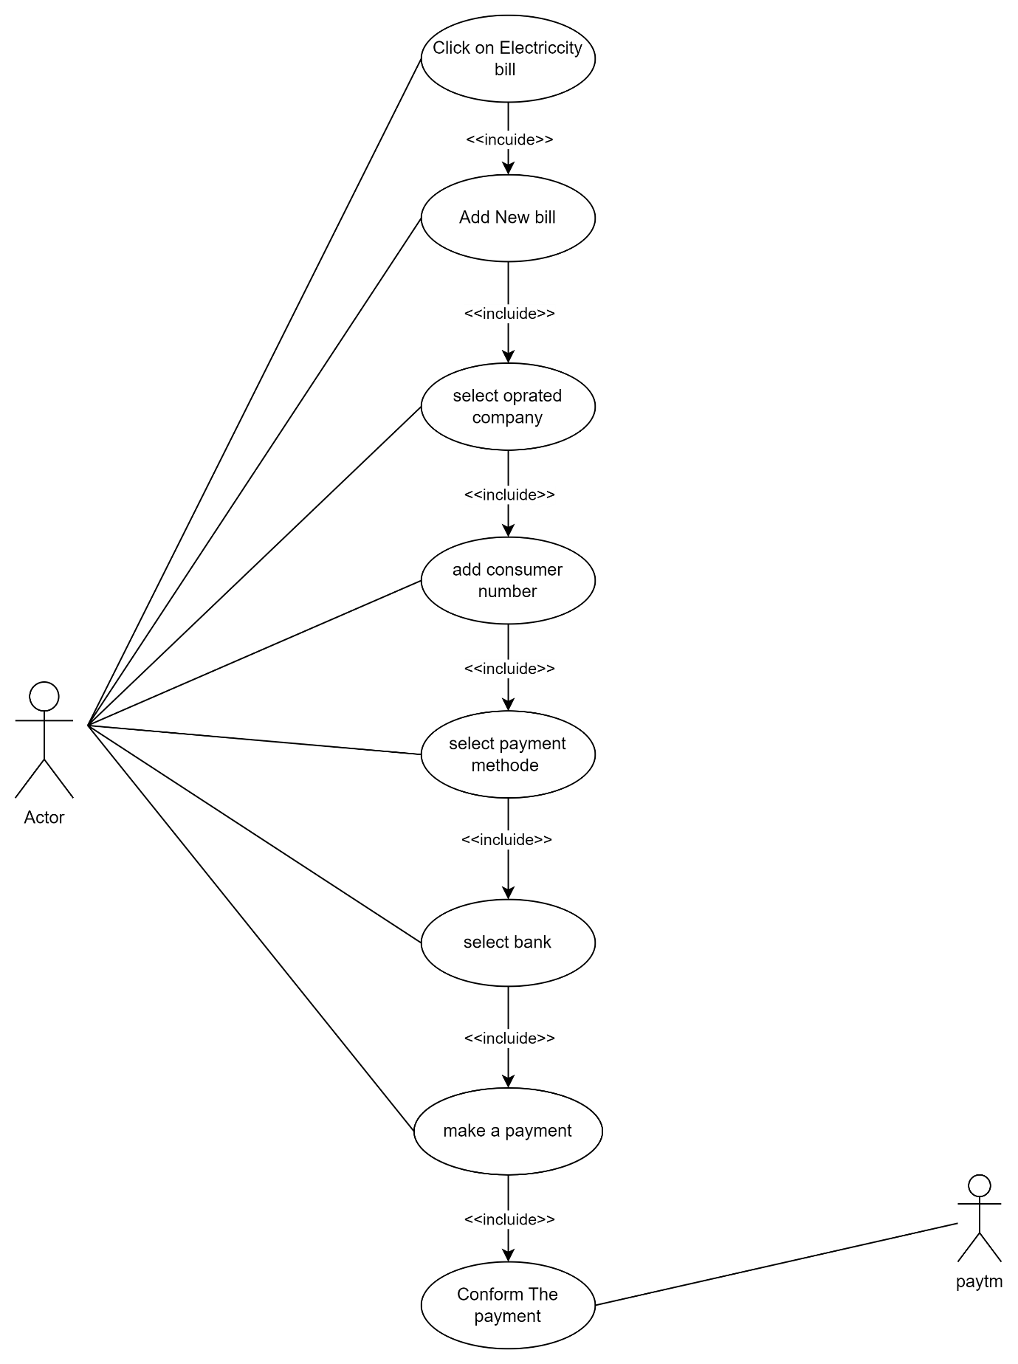

1. **Write SDLC phases with the introduction.**



* Requirement : customer needs
* Analysis : specify requirement
* Design :specify solution
* Implementation : construct solution in software
* Testing : solution against a requirement check
* Maintenance :repair and new requirement

1. **Explain phases of the waterfall model.**

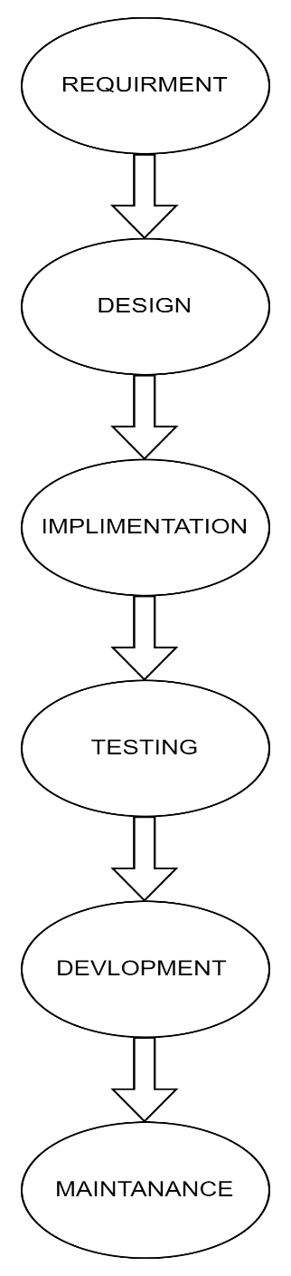

* Requirements must be “frozen”
* Requirements are validated too late

1. **Draw usecase on Online shopping product using COD?**

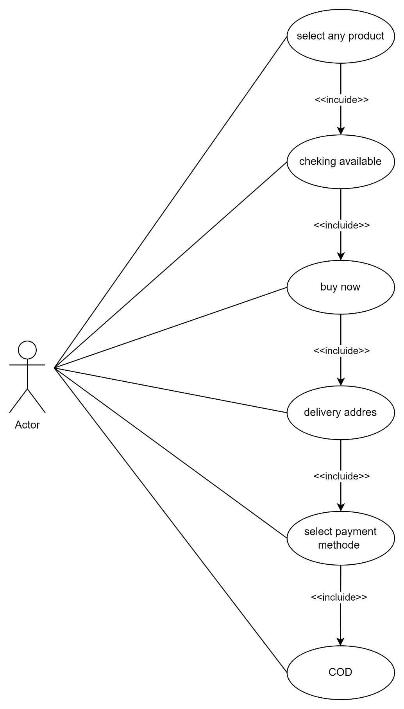

1. **Draw usecase on Online shopping product using payment gateway?**

